Lab-4

**For Windows and Virtual box:**

Answer (on the lab report):

* 1. What OS did you use as your host? Why?

I have been using windows from way back 2010 since my 7th grade. The OS system I used first was Windows Vista.

* 1. Familiarity with the OS (how long have you been using it)?

After that I used different flavors windows like Windows xp, xp professional, xp SP2 and SP3 windows 7 home , windows 7 Ultimate and currently using windows 11. I think I have been using windows for more than a decade for more than a decade.

* 1. Which hypervisor did you use? Why? What made you choose this one?

I started using Virtual box as it is open source and it’s free to download. Next I used VMware workstation player for some time as well.

* 1. Ensure that each VM has the ability to host 2 network ports and can use USB's as needed. Show me how you you did it.

For Virtual box:

goto>settings of the VM>Networks> enable the Network ports.

We need to install the extension pack of the virtual box to use the additional features.

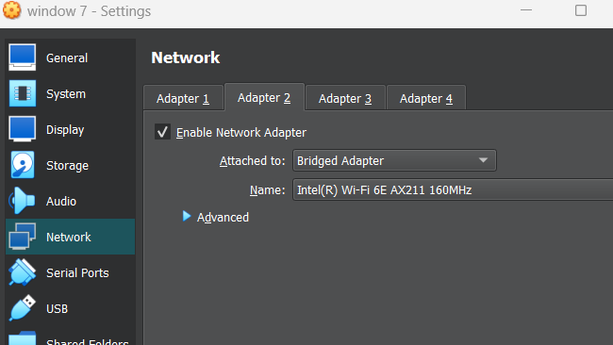’

In the above screenshot we can see the adapter 1 and 2 are enabled for windows 7 VM.

For USB:

Under usb tab we can the supported version of usb we can use. We can click on the ‘+’ add the existing device to from host to vm.

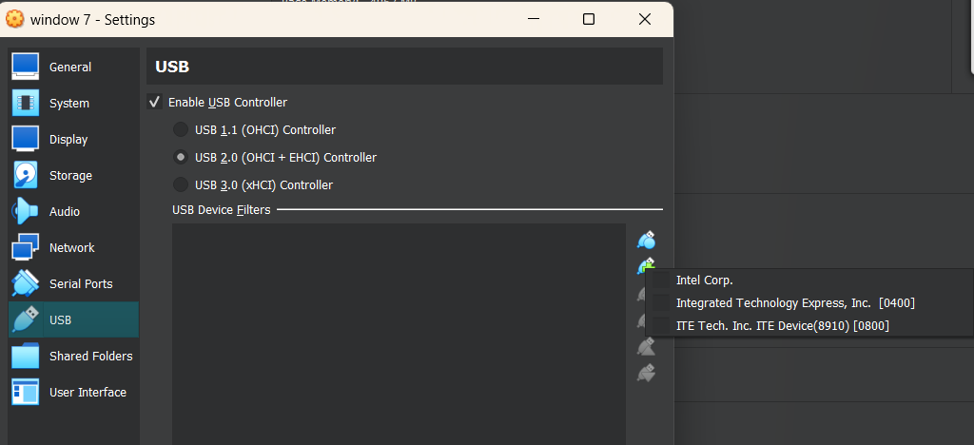

1. What did you find most challenging about the install (did you discover that some machines require that you turn on virtualization in the BIOS, etc)?

I enable the VTx tech in my bios beforehand itself. I faced warning that the windows hypervisor is turned on that needs to turned off to use the virtual box.

1. What would have done differently?

May be VMware doesn’t require the windows hypervisor to be turned off. I didn’t get any issue as it is turned off already when I was installing virtual box.

1. What recommendations would you make to someone doing this for the first time?

Go look at different videos on YouTube and forums online before installing anything new as it will give your idea different steps involved and what each step mean.

**For Linux and Qemu:**

What OS did you use as your host? Why?

I used Kali Linux has my host. To learn more about linux.

Familiarity with the OS (how long have you been using it)?

I have been using it for more than 5yrs till now. I have used different flavours of linux like Kali, Ubuntu, Fedora, Centos, Parrot, Archlinux (tired once).

Which hypervisor did you use? Why? What made you choose this one?

After doing some research, I found Linux too have a hypervisor that is Qemu. I couldn’t other alternatives to it. Only option available to my knowledge.

Ensure that each VM has the ability to host 2 network ports and can use USB's as needed. Show me how you you did it.

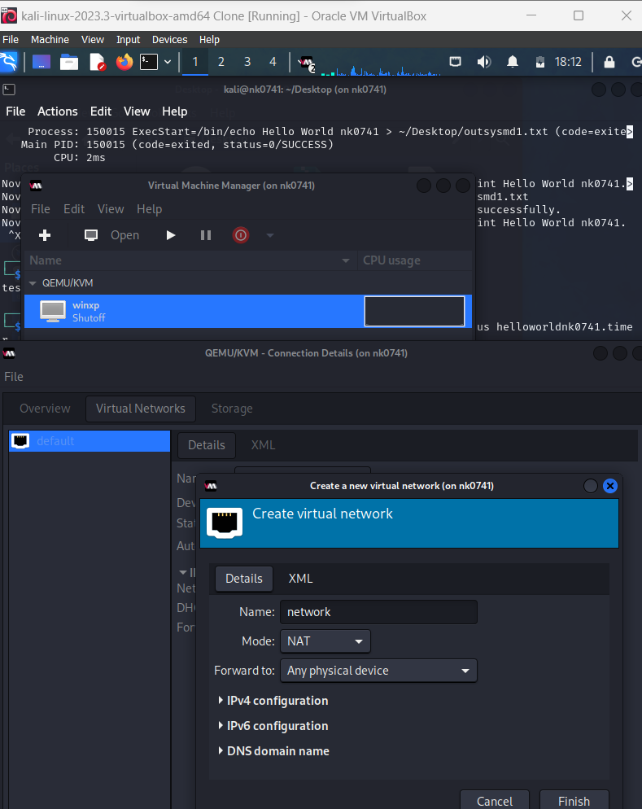

Goto> virtual manager> selectTheMachine>ConnectionDetails>virtual networks>clickOn’+’> add the Network

For USB:

We to goto storage under connectionDetails to add the new device from the list. Same has adding the network adapter.

What did you find most challenging about the install (did you discover that some machines require that you turn on virtualization in the BIOS, etc)?

I installed qemu on kali which is running on virtual box. So I didn’t have anything need to be changed from bios. The challenge I faced is that after installing the qemu, I didn’t get the gui for using and was forced to use the command and not sure what went wrong whenever I made a mistake. So, I installed the VirtMgnr for the GUI of Qemu.

What would have done differently?

Using the command line version and understanding the errors and resolving it to get better understanding than using the gui.

What recommendations would you make to someone doing this for the first time?

I recommend using windows version of hypervisor as it’s easy to install and use. Its gets the new user better understand the different aspects of the Hypervisor to get used it.

On virtual box: I have windows 7, xp, kali, Seed Ubuntu installed and ready to be used. Right now trying to install windows 8 for doing lab work.

